

DATA STRUCTURES AND ALGORITHM
23CSE203
LAB MANUAL

SUBMITTED BY
NAME | BIJIVEMULA SHANMUKHASAI
ROLL NO | AV.SC.U4CSE25021
YEAR/SEM/SECTION | 2nd YEAR /SEM-3/CSE A
CREDITS | 05

SUBMITTED TO | DR. RAJ KUMAR BATCHU
DESIGNATION | ASST.PROFFESSOR (Sl. Grade)
DEPARTMENT | SCHOOL OF COMPUTING

INDEX

SNO (lab) | PROGRAM | PAGE NO
Lab 1 | 1: A rocket launch system displays a countdown before launch. Instead of using a loop, implement the countdown using recursion. Write a recursive Python program to display a countdown from n to 1, followed by “launch”.  2: Banks calculate the growth of an investment using compound interest. The formula requires calculating powers. Which can be implemented recursively. Write a recursive program to calculate p^n(power), where p=principal growth factor, n= number of years  3: An HR department stores employee ID’s in a list. Develop a recursive program to search for a given employee ID. Write a recursive function to search for an employee ID in a list.  4: In a logistics company, the number of possible ways to arrange n different parcels is calculated using the factorial formula(n!). Develop a recursive program to calculate the factorial of a given number  5: Write a recursive Python program to print the first n terms of the Fibonacci series. | 3-9

LAB -1
1)AIM: A rocket launch system displays a countdown before launch. Instead of using a loop, implement the countdown using recursion. Write a recursive Python program to display a countdown from n to 1, followed by “launch”.
PROGRAM:
def launch(n):
for i in range(n,-1,-1):
if i==0:
print("launch"):
else:
print(i)
n=int (input ("enter no. of seconds to launch:"))
launch(n)
OUTPUT:
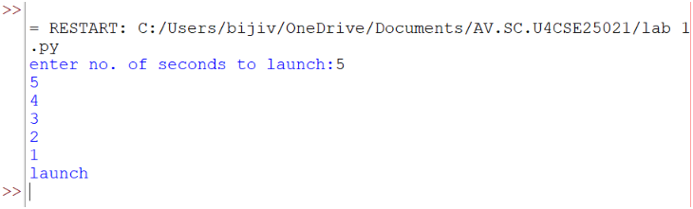
EXPLANATION:
This program displays a countdown from n to 1 and finally prints 'launch'. Although the aim mentions recursion, the given code uses a loop.

ERROR TABLE:
ERROR | CAUSE | SOLUTION
Indentation Error | Incorrect indentation | Align blocks properly
Name Error | Variable not defined | Define before use
Value Error | Non-integer input | Enter a valid integer

2)AIM: Banks calculate the growth of an investment using compound interest. The formula requires calculating powers. Which can be implemented recursively. Write a recursive program to calculate p^n(power), where p=principal growth factor, n= number of years.
PROGRAM:
def intrest(p,n):
if n==0:
return 1
else:
return p*intrest(p,n-1)
n=int(input("enter no.of years:"))
p=int(input("enter a number:"))
res=intrest(p,n)
print(res)
OUTPUT:
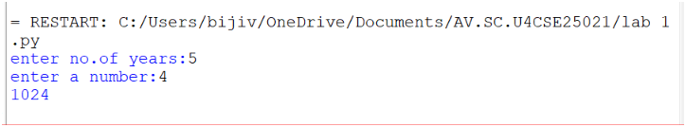

EXPLANATION:
This program recursively calculates p^n by multiplying p until n becomes 0.
ERROR TABLE:
ERROR | CAUSE | SOLUTION
Recursion error | Very large value of n | Reduce input
Name Error | Wrong function/variable name | Check spelling
Value Error | Non-integer input | Enter a valid integer

3)AIM: An HR department stores employee ID’s in a list. Develop a recursive program to search for a given employee ID. Write a recursive function to search for an employee ID in a list.
PROGRAM:
def search(m)
key=m
for i in range(n-1):
if arr[i]==key:
return i
n=int(input("enter no.of employees to add:"))
arr=[]
for i in range(n):
a=int(input("enter a value:"))
arr.append(a)
print(arr)
m=int(input("enter a element to search:"))
result=search(m)
if result==-1:
print(“element is not found”)
else:
print("employee id is stored at the index:",result)
OUTPUT:
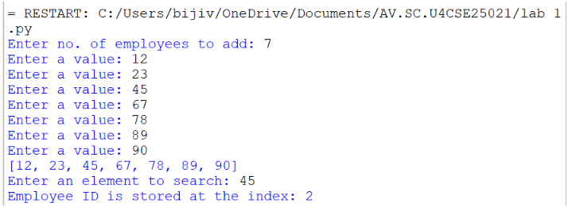
EXPLANATION:
This program searches for an employee ID in a list and returns its index if found.
ERROR TABLE:
ERROR | CAUSE | SOLUTION
Syntax error | Wrong quotes/brackets | Correct syntax
Logic error | Returns None instead of -1 | Return -1 when not found

4)AIM: In a logistics company, the number of possible ways to arrange n different parcels is calculated using the factorial formula(n!). Develop a recursive program to calculate the factorial of a given number.

PROGRAM:
def fact(n):
fact=1
for i in range(1,n+1):
fact=fact*i

return fact
n=int(input("enter a number to find its factorial:"))
result=fact(n)
print(result)
OUTPUT:
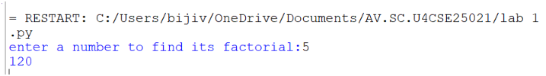

EXPLANATION:
This program calculates the factorial of a number using iteration (not recursion).
ERROR TABLE:
ERROR | CAUSE | SOLUTION
Overflow/large input | Large input value | Give smaller input
Value error | Invalid input | Even integer

5)AIM: Write a recursive Python program to print the first n terms of the Fibonacci series.

PROGRAM:
def fib(n):
if n==0:
return 0
elif n==1:
return 1
else:
return fib(n-1)+fib(n-2)

n=int(input("enter no of terms:"))
if n<=-1:
print("invalid input")
else:
for i in range(n):
print(fib(i),end=" ")
OUTPUT:
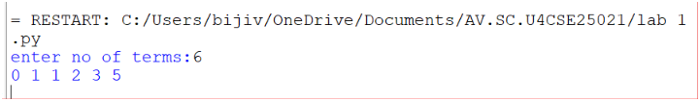
EXPLANATION:
The program uses recursion to generate Fibonacci numbers. fib (0)=0 and fib (1) =1 are the base cases. For every other term, fib(n)=fib(n-1) + fib(n-2). The loop prints the first n terms.

ERROR TABLE:
ERROR | CAUSE | SOLUTION
Recursion error | Large value of n | Use iteration
Invalid input | Negative value of n | Validate input
Slow execution | Repeated recursive calls | Use dynamic programming

PROGRAM | TIME COMPLEXITY | SPACE COMPLEXITY | REASON
1. countdown to launch | O(n) | O (1) | The program uses a loop that prints from n to 0 once.
2. Power calculation | O(n) | O(n) | One recursive call is made for each value of n—the recursion stack stores n calls.
3. Employee ID search | O(n) | O (1) | The program performs a linear search through the list.
4.Factorial | O(n) | O (1) | The program calculates factorial using a loop from 1 to n.
5. Fibonacci series | O(2ⁿ) | O(n) | Each function call creates two additional recursive calls, leading to exponential time complexity. The recursion stack reaches depth n.

Lab 2
1.AIM: Write a program to perform linear search on a given input.
PROGRAM:
def linear_search(arr,key):
for i in range(len(arr)):
if arr[i]==key:
return i
return -1

n = int(input("Enter no. of elements:"))
arr=[]
print("Enter the elements:")
for i in range(n):
arr.append(int(input()))
key=int(input("Enter element to search:"))
result=linear_search(arr,key)
if result!=-1:
print("Element found at index",result)
else:
print("Element not found.")
OUTPUT:
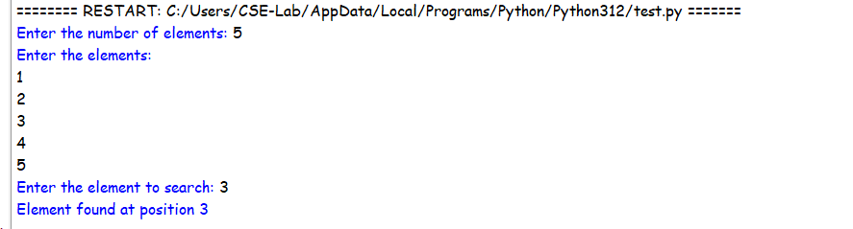
EXPLANATION:
- The linear_search() function checks each element of the list one by one and compares it with the given key.
- If the key is found, its index is returned; otherwise, the function returns -1.
- The program takes the array and search element as input and displays whether the element is found.
ERROR TABLE:
S.no. | Errors | Rectification
1. | ValueError occurs if a non-integer value is entered when int(input()) is used. | Enter only integer values for the number of elements and array elements.
2. | TypeError may occur if len(arr) is used on a variable that is not a list. | Make sure arr is initialized as a list using arr = [] and elements are appended to it.

2.AIM: Write a Python program to perform binary search on the given input. Verify by taking sorted array and unsorted array as input.
PROGRAM:
def binary_search(arr,key):
low=0
high=len(arr)-1
while low<=high:
mid=(low+high)//2
if arr[mid]==key:
return mid
elif arr[mid]<key:
low=mid+1
else:
high=mid-1
return -1

n = int(input("Enter no. of elements:"))
arr=[]
print("Enter the elements:")
for i in range(n):
arr.append(int(input()))
key=int(input("Enter element to search:"))
result=binary_search(arr,key)
if result!=-1:
print("Element found at index",result)
else:
print("Element not found.")
OUTPUT:
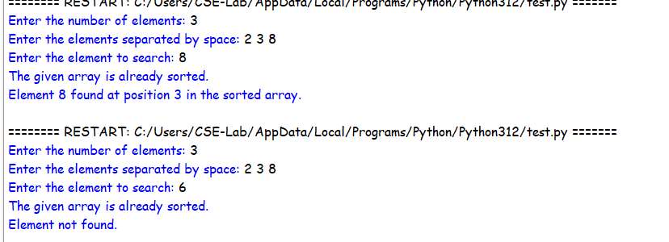
3.PROGRAM:
def binary_search(arr,key):
low=0
high=len(arr)-1
while low<=high:
mid=(low+high)//2
if arr[mid]==key:
return mid
elif arr[mid]<key:
low=mid+1
else:
high=mid-1
return -1

n = int(input("Enter no. of elements:"))
arr=[]
print("Enter the elements:")
for i in range(n):
arr.append(int(input()))
if arr==sorted(arr):
print("\n The input list is already sorted.")
else:
print("\n The input list is not sorted.")
print("Sorting the list...")
arr.sort()
print("Sorted list.",arr)
key=int(input("Enter element to search:"))
result=binary_search(arr,key)
if result!=-1:
print("Element found at index",result)
else:
print("Element not found.")

OUTPUT:

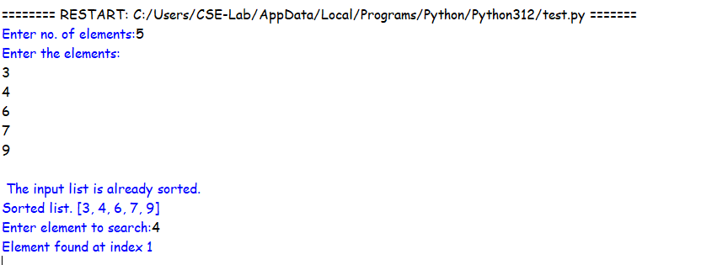
EXPLANATION:
- The binary_search() function repeatedly divides the sorted list into two halves and compares the middle element with the search key.
- If the middle element is smaller than the key, the search continues in the right half; otherwise, it searches the left half.
- The second program verifies whether the input is sorted and sorts it using arr.sort() if necessary before performing binary search.

ERROR TABLE:
S.no. | Errors | Rectification
1. | Binary search may give an incorrect result if the input array is unsorted. | Check whether the array is sorted and use arr.sort() before calling binary_search().
2. | IndexError can occur if mid is calculated or the low/high boundaries are modified incorrectly. | Initialize low = 0, high = len(arr) - 1 and update them as low = mid + 1 or high = mid - 1.

LAB-3
AIM: 3a. Write a python program to sort the elements using a bubble sort technique. Take the input elements from the user.
Program:
n = int(input("Enter the number of elements: "))
arr = []
print("Enter the elements:")
for i in range(n):
arr.append(int(input()))
for i in range(n - 1):
for j in range(n - i - 1):
if arr[j] < arr[j + 1]:
arr[j], arr[j + 1] = arr[j + 1], arr[j]
print("Elements after Bubble Sort:")
print(arr)
Output:
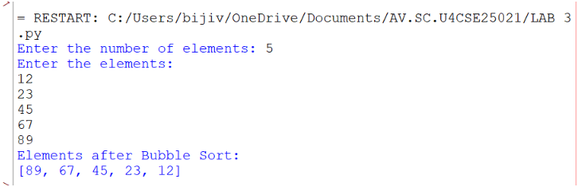
Explanation:
• n = int(input(...)) – Gets the number of elements.
• arr = [] – Creates an empty list to store elements.
• for i in range(n) – Takes n elements as input.
• arr.append(...) – Adds each element to arr.
• for i in range(n - 1) – Performs Bubble Sort passes.
• for j in range(n - i - 1) – Compares adjacent elements.
• if arr[j] < arr[j + 1] – Checks if the current element is smaller.
• arr[j], arr[j + 1] = ... – Swaps the elements to sort in descending order.
• print(arr) – Displays the sorted list.
Error Table:
S.NO | Error Obtained | Rectification
1. | Sorting Order Error – Using > instead of < in the if condition changes the order to ascending. | Use if arr[j] < arr[j + 1]: for descending order.

AIM: 3b.Write a python program to sort the elements using a insertion sort technique. Take the input elements from the user.
Program:
def insertion_sort(arr):
n = len(arr)
for i in range (1,n):
key = arr[i]
j = i - 1
while j >= 0 and arr[j] > key:
arr[j+1] = arr[j]
j = j - 1
arr[j+1] = key
return arr
n = int(input("Enter the number of elements: "))
arr = []
print("Enter the elements:")
for i in range(n):
element = int(input())
arr.append(element)
result = insertion_sort(arr)
print("Elements after Insertion Sort:")
print(result)
Output:
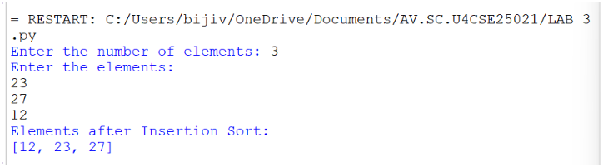
Explanation:
• n = len(arr) – Gets the list size.
• for i in range(1, n) – Selects elements from the second position.
• key = arr[i] – Stores the current element.
• j = i - 1 – Sets the previous index.
• while j >= 0 and arr[j] > key – Compares previous elements with key.
• arr[j + 1] = arr[j] – Shifts larger elements right.
• arr[j + 1] = key – Inserts key in the correct position.
• return arr – Returns the sorted list.
• result = insertion_sort(arr) – Calls the function.
• print(result) – Displays the sorted list.
ERROR TABLE:
S.NO | Error Obtained | Rectification
1. | Insertion Error – Placing key at the wrong index. | Use arr[j + 1] = key after shifting elements.
2. | Function Call Error – Not calling insertion_sort(arr) correctly. | Pass the input list arr to the function.

AIM: 3c.Write a python program to sort the elements using a selection sort technique. Take the input elements from the user.
Program:
def selection_sort(arr):
n=len(arr)
for i in range(n-1):
min_index=i
for j in range (i+1,n):
if arr[j]<arr[min_index]:
min_index=j
arr[i],arr[min_index]=arr[min_index],arr[i]
return arr
n=int(input("Enter the number of elements: "))
arr=[]
print("Enter the elements:")
for i in range(n):
element=int(input())
arr.append(element)
result=selection_sort(arr)
print("Elements after Selection Sort:")
print(result)
Output:
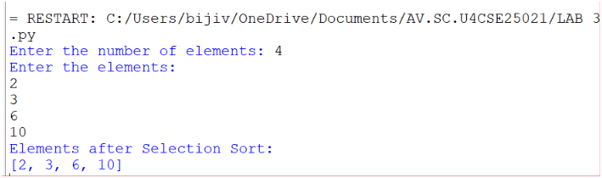
Explanation:
• def selection_sort(arr) – Defines the Selection Sort function.
• n = len(arr) – Gets the number of elements in arr.
• for i in range(n-1) – Performs sorting passes.
• min_index = i – Assumes the first element is the smallest.
• for j in range(i+1,n) – Checks the remaining elements.
• if arr[j] < arr[min_index] – Finds the smallest element.
• arr[i], arr[min_index] = ... – Swaps the smallest element into position.
• return arr – Returns the sorted list.
• result = selection_sort(arr) – Calls the function.
• print(result) – Displays the sorted list in ascending order.

Error Table:
S.NO | Error Obtained | Rectification
1. | Swap Error – Incorrectly swapping the elements. | Use arr[i], arr[min_index] = arr[min_index], arr[i].
2. | Minimum Index Error – Incorrectly assigning min_index. | Use min_index = i.

AIM: 3d.Write a python program to sort the elements using a merge sort technique. Take the input elements from the user.
Program:
def merge_sort(arr):
if len(arr) <= 1:
return arr
mid=len(arr)//2
left=merge_sort(arr[:mid])
right=merge_sort(arr[mid:])
i = j = k = 0
while i < len(left) and j < len(right):
if left[i] <= right[j]:
arr[k] = left[i]
i += 1
else:
arr[k] = right[j]
j += 1
k += 1
while i < len(left):
arr[k] = left[i]
i += 1
k += 1
while j < len(right):
arr[k] = right[j]
j += 1
k += 1
return arr
n = int(input("Enter the number of elements: "))
arr = []
print("Enter the elements:")
for i in range(n):
element = int(input())
arr.append(element)
result = merge_sort(arr)
print("Elements after Merge Sort:")
print(result)
Output:
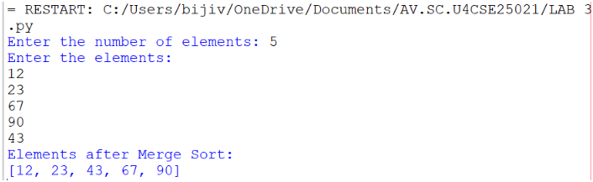
Explanation:
• def merge_sort(arr) – Defines the Merge Sort function.
• if len(arr) <= 1 – Stops when the list has one or no elements.
• mid = len(arr)//2 – Finds the middle of the list.
• left and right – Divide the list into two halves recursively.
• i = j = k = 0 – Initializes the indexes.
• while loops – Compare and merge the elements.
• if left[i] <= right[j] – Selects the smaller element.
• arr[k] – Places the selected element in the list.
Error Table:
S.NO | Error Obtained | Rectification
1. | Index Error – Incorrectly updating i, j, or k. | Increment the appropriate index after each insertion.
2. | Recursion Error – Incorrectly dividing the list. | Use arr[:mid] and arr[mid:].
AIM: 3e.Write a python program to sort the elements using a quick sort technique. Take the input elements from the user.
Program:
def quicksort(a,low,high):
if low < high:
i = low
j = high
pivot = low
while i < j:
while i < len(a) and a[i]<=a[pivot]:
i +=1
while a[j] > a[pivot]:
j = j -1
if i < j:
a[i],a[j] = a[j],a[i]
a[j],a[pivot] = a[pivot],a[j]
quicksort(a,low,j-1)
quicksort(a,j+1,high)
a = list(map(int,input("Enter numbers to sort:").split(" ")))
n = len(a)
quicksort(a,0,n-1)
print("Sorted array:")
print(a)
Output:
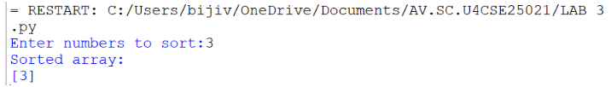

Explanation:
• def quicksort(a, low, high) – Defines the Quick Sort function.
• if low < high – Checks the sorting range.
• i and j – Set left and right positions.
• pivot = low – Selects the first element as pivot.
• while i < j – Performs partitioning.
• Inner while loops – Find elements for swapping.
• a[i], a[j] = ... – Swaps elements.
• a[j], a[pivot] = ... – Places the pivot correctly.
• quicksort() calls – Sort the two partitions.
• input().split() – Takes space-separated numbers.
• print(a) – Displays the sorted array.

Error Table:
S.NO | Error Obtained | Rectification
1. | Pivot Error – Incorrectly selecting the pivot index. | Use pivot = low.
2. | Swap Error – Incorrect swapping of a[i] and a[j]. | Use a[i], a[j] = a[j], a[i].

